CLIMAAX PROJECT INTRODUCTION EVENT
06.08.2025 MERSİN METROPOLITAN MUNICIPALITY
DEPARTMENT OF CLIMATE CHANGE AND ZERO WASTE

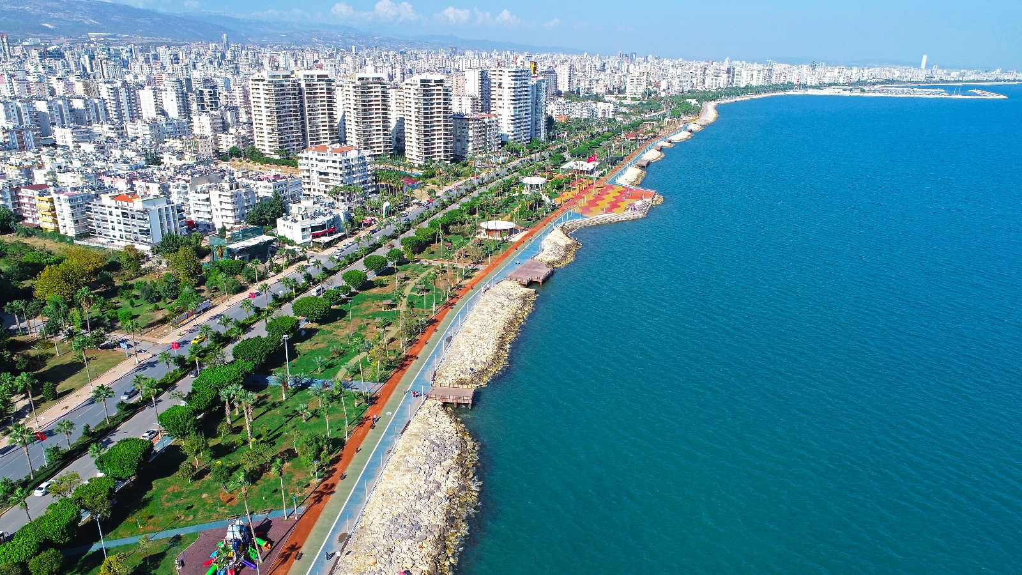
MCR-RA MERSİN READY FOR CLIMATE:
MULTI-HAZARD RISK ASSESSMENT FOR URBAN, COASTAL, AND RURAL RESILIENCE

INTRODUCTION EVENT REPORT

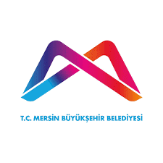

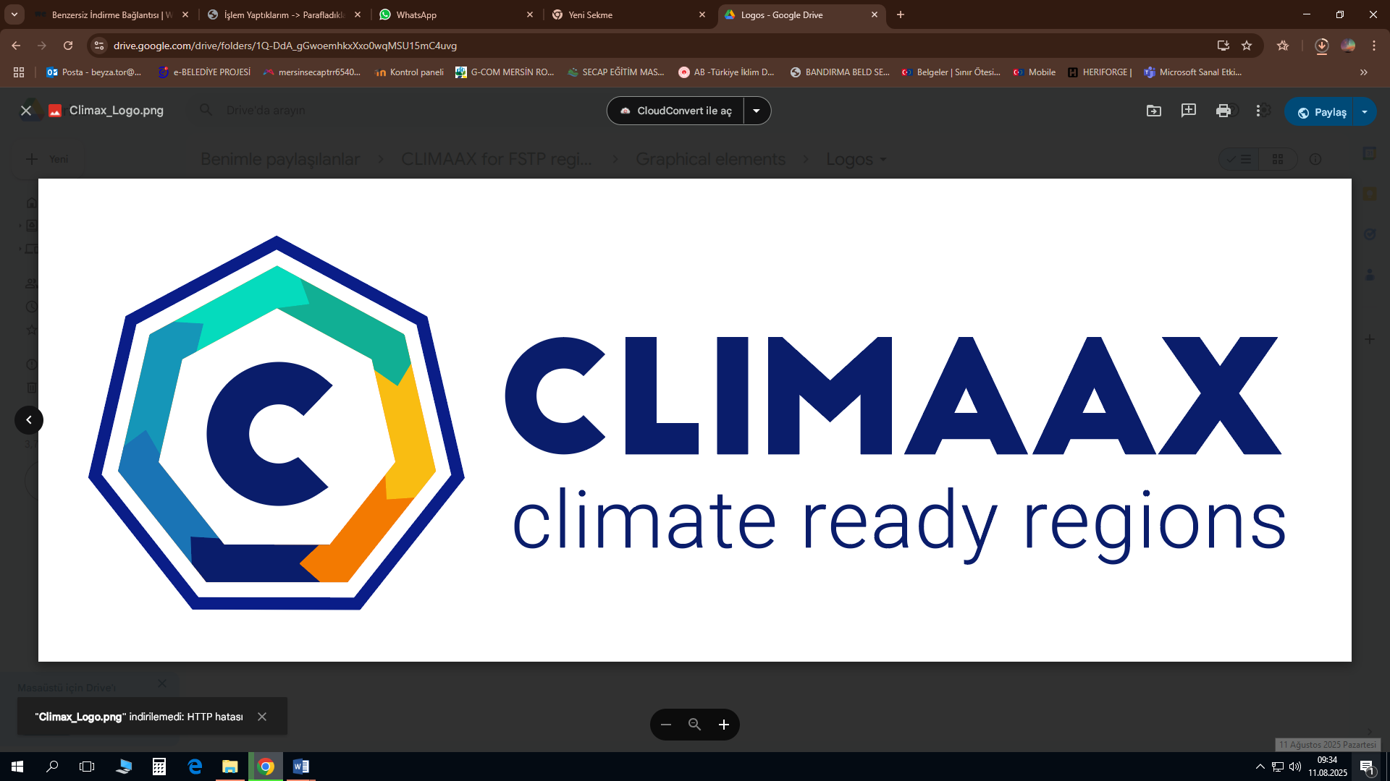

Address: Kültür Mah. Eski Marina Vista Avm, 4304 Sk. No:1, Akdeniz/Mersin
Phone: 185
WhatsApp: 903241850000
E-mail: teksin.mersin@mersin.bel.tr

INTRODUCTION
Mersin, located on the eastern coast of the Mediterranean, is one of Turkey’s most important hubs for logistics, agriculture, and tourism. The impacts of the global climate crisis—such as heatwaves, drought, flash floods, and forest fires—directly affect the city’s social, economic, and ecological structure. The Mersin Metropolitan Municipality stands out as a pioneering local government in climate change adaptation and sustainability at the international level.
As a member of ICLEI – Local Governments for Sustainability, it benefits from global knowledge networks in sustainable urban planning.
As a signatory of the Global Covenant of Mayors for Climate & Energy (GCoM), it sets emission reduction and adaptation targets in line with international standards.
By sharing transparent climate data through the CDP-ICLEI Track platform, it strengthens accountability and monitoring mechanisms.
These memberships position Mersin as a model city for climate resilience and green transformation in the Mediterranean region.
The MCR-RA “Mersin Ready for Climate: Multi-Hazard Risk Assessment for Urban, Coastal, and Rural Resilience” project has been implemented within the framework of the EU-supported CLIMAAX initiative. The project’s objectives are:
- Scientifically analyzing multiple climate risks
- Developing adaptation strategies for urban, coastal, and rural areas
- Strengthening local capacity and increasing social awareness
- Institutionalizing data-driven decision-making processes
The rest of the report contains detailed sections on:
- Project introduction
- Workflows and technical approach
- Heatwaves, drought, flooding, and forest fire risks for Mersin
- Stakeholder workshop discussions with short- and long-term adaptation strategies
- Survey results showing public perception of climate threats

The report concludes by emphasizing Mersin’s commitment to using global expertise from ICLEI and GCoM to produce local solutions through the CLIMAAX-supported MCR-RA project.

PROJECT INTRODUCTION

The MCR-RA “Mersin Ready for Climate: Multi-Hazard Risk Assessment for Urban, Coastal, and Rural Resilience” Project Introduction and Workshop Event aimed to develop a joint roadmap for addressing Mersin’s climate risks through the participation of stakeholders from various sectors. During the event, held on 06 August 2025, the opening remarks and project introduction, along with details about the application processes, were presented by Dr. Zafer Kuşatan, Head of the Climate Change and Renewable Energy Branch at the Department of Climate Change and Zero Waste, Mersin Metropolitan Municipality:

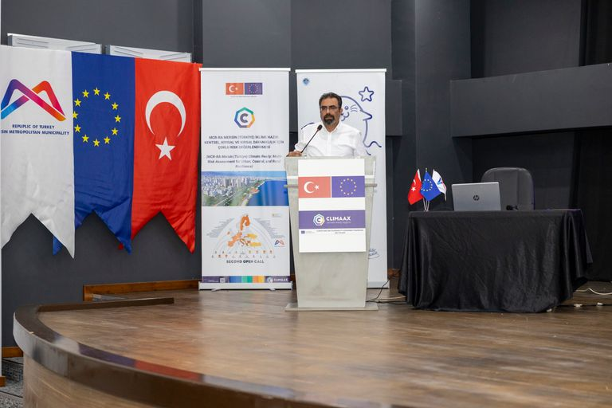
“As a coastal city, Mersin has high climate sensitivity due to its economic activities and urbanization challenges. The aim of the project is to analyze Mersin’s vulnerabilities to climate change, assess climate risks, and strengthen climate adaptation strategies.”

He further stated:
“From the perspective of climate vulnerability, Mersin is among the top four cities in Turkey most exposed to climate change. The project will holistically assess climate risks using both EU and local climate projections, applying the CLIMAAX methodology. The ‘Mersin Ready for Climate’ initiative is not merely a project but a strategic transformation tool that builds our province’s capacity to respond to climate change in a systematic, inclusive, and long-term manner.”
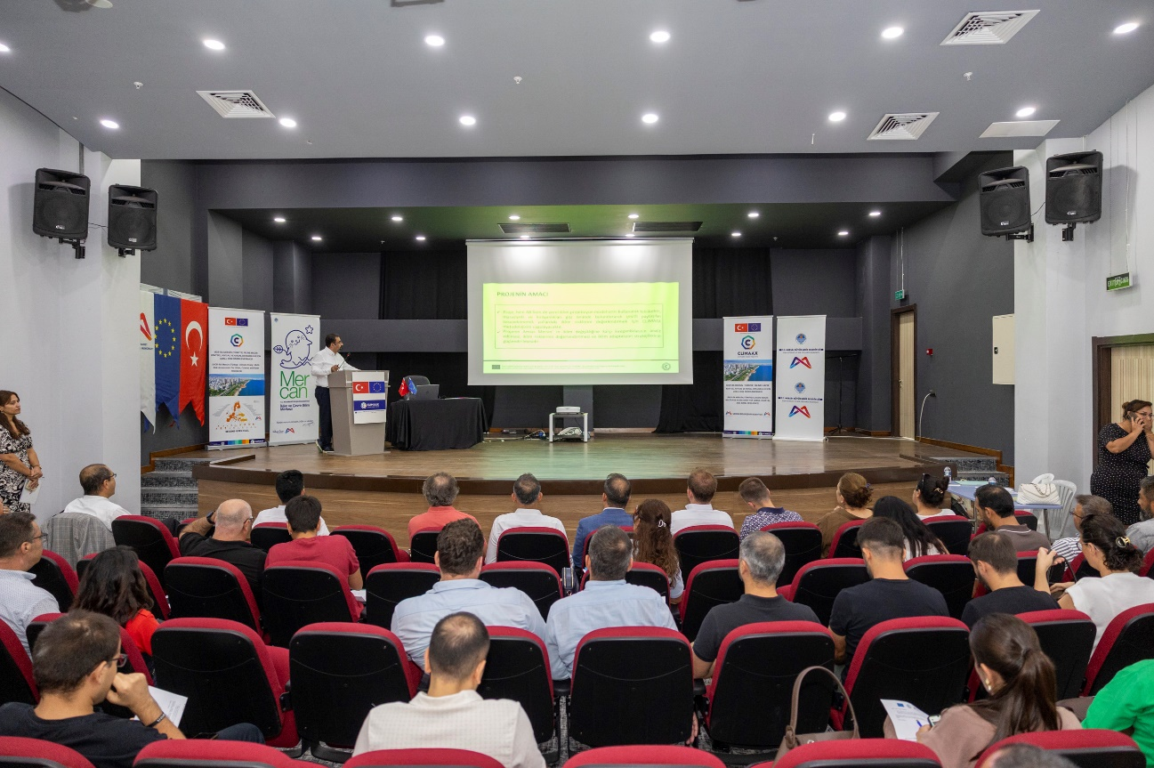

Project Specialist and Electrical & Electronics Engineer Hakan Duman added:
“The CLIMAAX and Pathways2Resilience projects are initiatives financed under the European Union’s Horizon Europe program. Both projects aim to support regions and communities in adapting to climate change and increasing their resilience.”
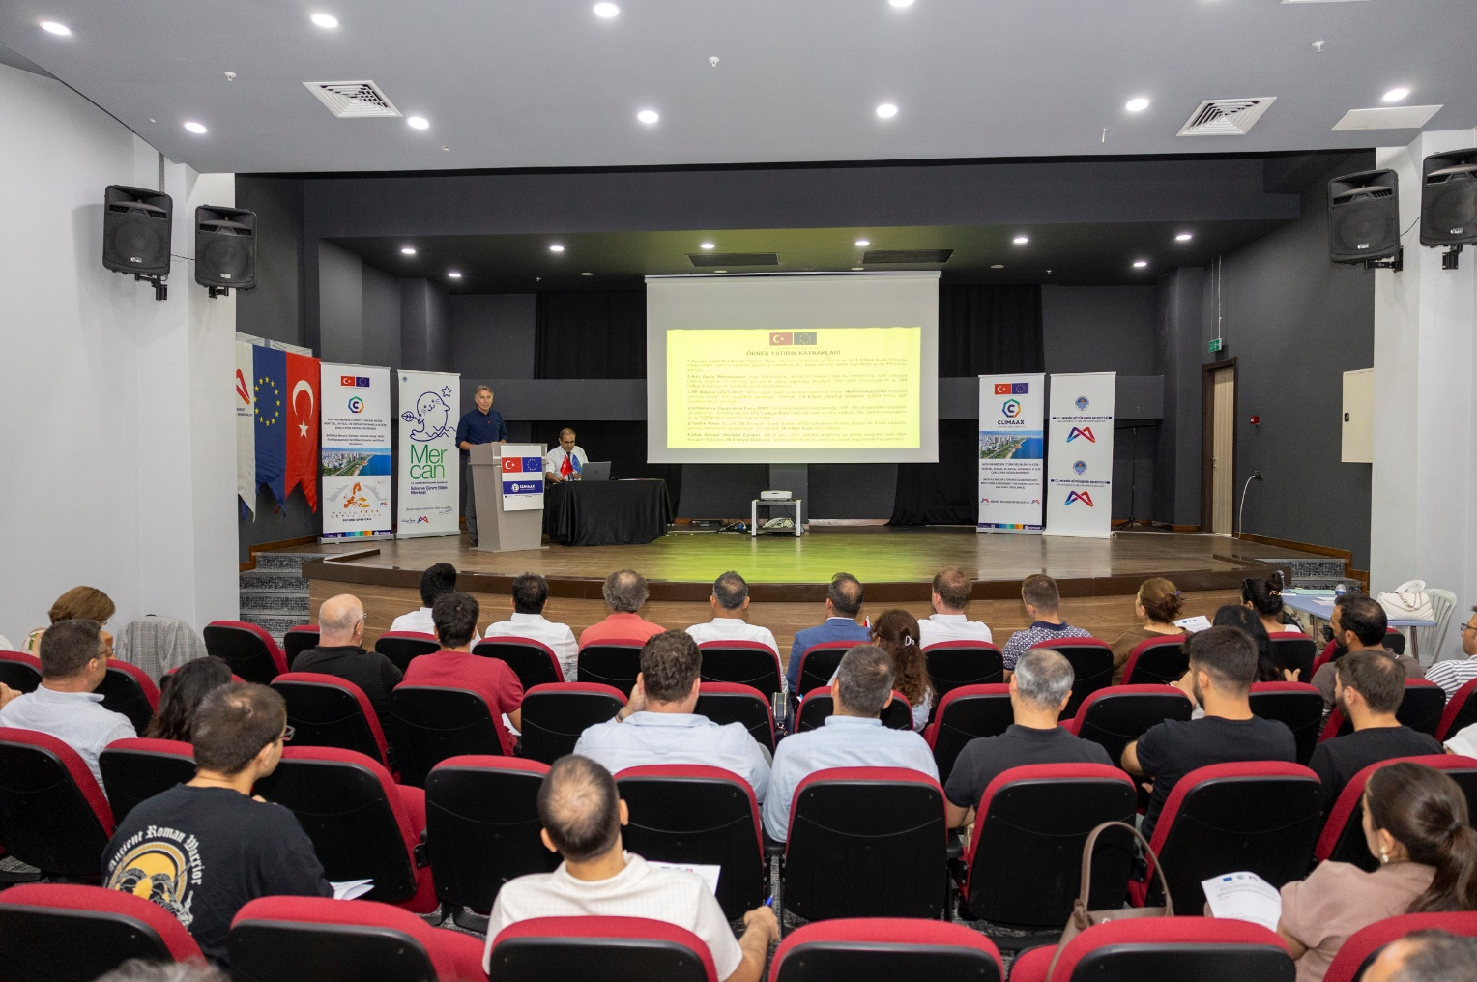

WORKFLOWS
The workflows and technical approach of the project were presented by Environmental Engineer Tamer Atalay, highlighting four main climate risks for the Mersin region:

1. Heatwaves
- By 2050, the number of heatwave days based on perceived temperature in Mersin is expected to increase to 37 days per year, representing a 100% increase compared to current conditions.
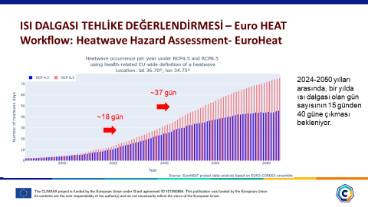
- The Mersin region currently experiences 60 days per year with high Universal Thermal Climate Index (UTCI) values and 20 days per year with high perceived temperature–based heatwave indices.
- By combining satellite-derived land surface temperature data (Landsat-8) with vulnerable population density data, an urban heatwave risk map has been created to identify high-risk neighborhoods in the Mersin city center.
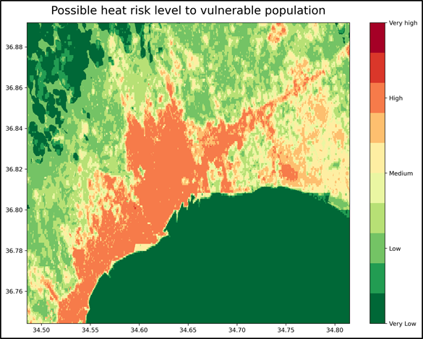
Urban Heatwave Risk Map – High-risk neighborhoods in Mersin city center

2. Drought
- While the current Relative Drought Risk in Turkey is 1, under the pessimistic 2050 scenario (RCP8.5), this risk is projected to rise to 2.
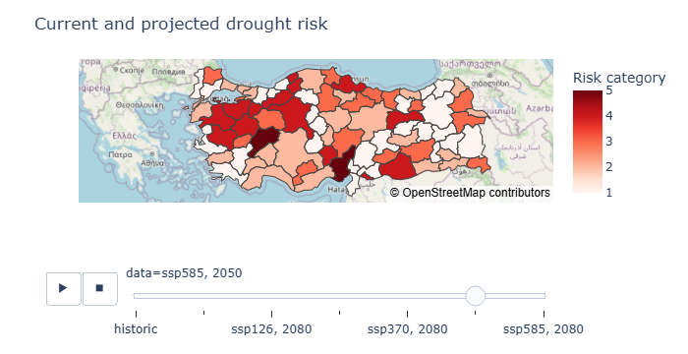
While the current Relative Drought Risk in Turkey is 1, under the pessimistic 2050 scenario (RCP8.5)
- The average annual precipitation in Mersin is around 650 mm. The Standard Evapotranspiration (ET₀) is currently 1,300 mm, but is expected to rise to 2,500 mm by 2050.
- High evapotranspiration combined with low annual rainfall will increase the demand for artificial irrigation. This may lead to yield losses due to insufficient irrigation: by 2050, losses are expected to be 24–40% in citrus and 35–45% in bananas.

3. Floods
- Extreme precipitation events and sea-level rise are significant climate risks for Mersin.
- For a 10-year return period, the 3-hour precipitation amount is approximately 40 mm, while the 24-hour precipitation amount is 140–150 mm.
- No major overall increase is expected in these values by 2050, but some areas are projected to see increases of 25–50%.
- Maps indicating areas at risk from sea-level rise by 2050 were also presented in the session.
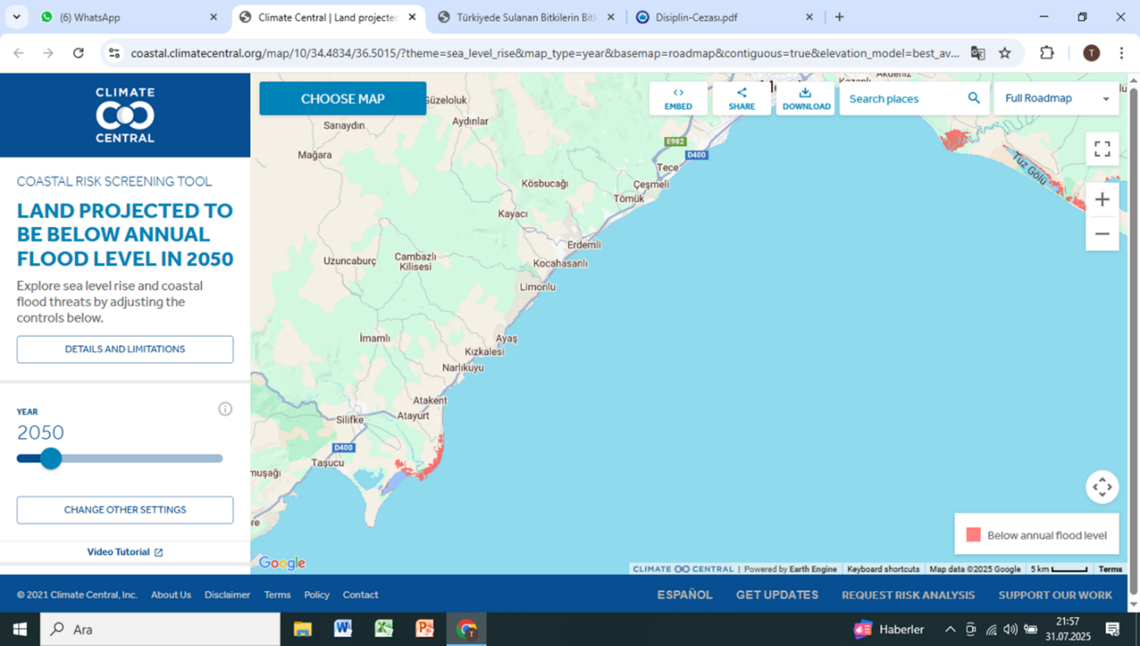

4. Forest Fires
- Forest fire risk is assessed using the Fire Weather Index (FWI). Days with FWI > 30 indicate an “Extremely High” risk level.
- Projected increases in temperature and decreases in precipitation will raise the risk of forest fires.
- According to projections, average temperature increases will be +1°C in the 2030s, +2–3°C in the 2060s, and above +3°C in the 2090s, with corresponding decreases in precipitation of 10% in the 2030s and 20% in the 2060s and 2090s.
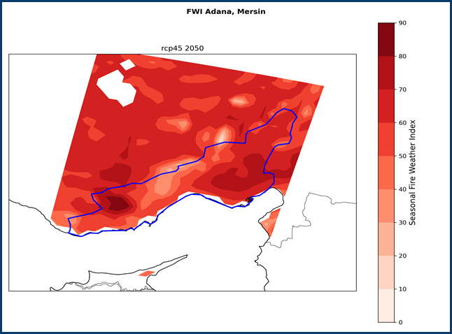
Maps showing the increase in the number of days with FWI > 30 by 2050 were shared.
After the detailed presentation of the four main climate risks, a Menti survey was conducted.
When asked about the most significant climate hazards in Mersin, participants identified:
- Forest fires – 97%
- Heatwaves – 95%
- Drought – 87%
- Extreme rainfall and surface flooding – 58%
Following the survey, stakeholders worked together to evaluate risk scenarios, combining local knowledge with scientific analysis.
An interactive and written workshop session was held under four main topics: Heatwaves, Drought, Surface and Coastal Flooding, and Forest Fires.
Both short-term and long-term solutions were discussed under each topic.
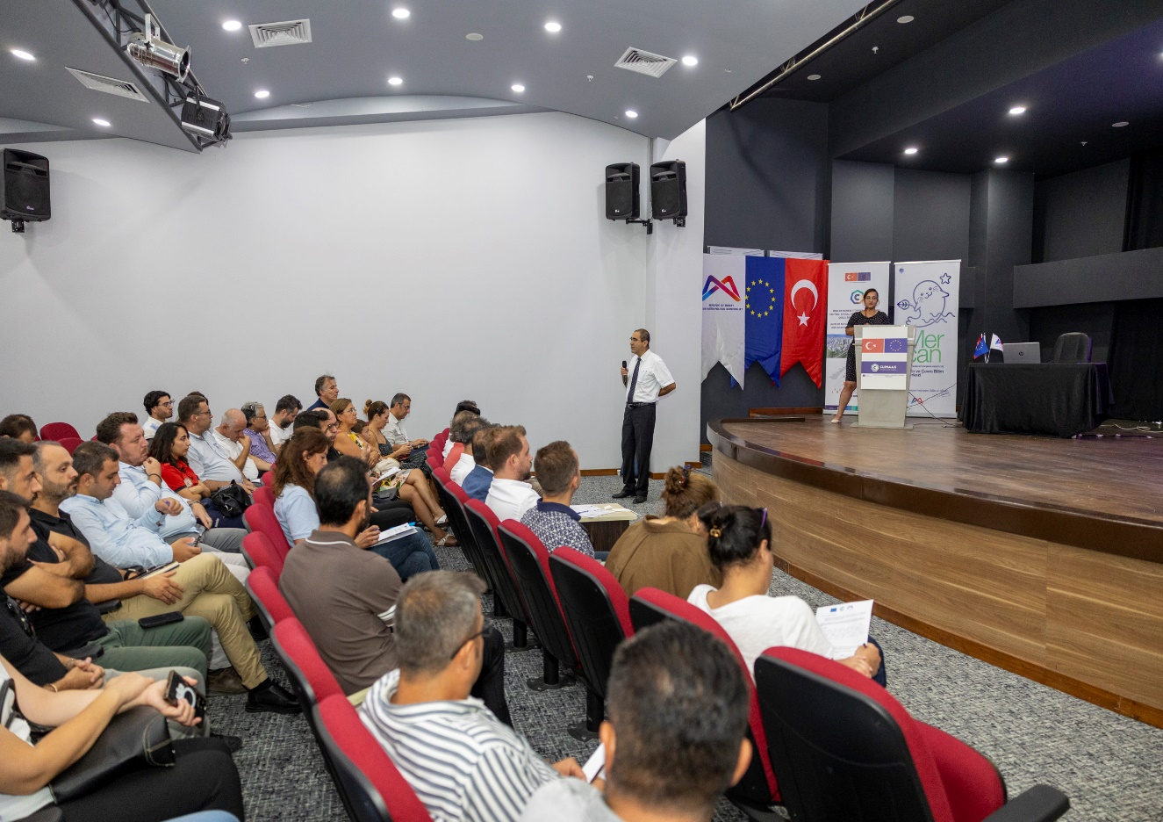

WORKSHOP SESSION

1. Heatwaves
Short-Term Solutions: Cooling centers, water stations, early warning systems, awareness campaigns.
Long-Term Solutions: Strengthening the green space network, promoting insulated building standards, implementing nature-based shading solutions, GIS-based heat island monitoring.
Stakeholder Comments:
- Mersin Metropolitan Municipality Women and Family Services Department: Increase the amount of green space threefold, ensuring a maximum access distance of 300 meters to green areas.
- Chamber of Agriculture: Increase the number of North–South arterial roads (as most current roads are oriented East–West, which also aids stormwater drainage), and consider prevailing wind direction in urban planning.
- Regional Directorate of Forestry: Implement green belt planning, prepare afforestation strategies for the future, and detail these plans into short-, medium-, and long-term periods; irrigation should be supported with rainwater collection.

2. Drought
Proposed Solutions: Climate data-based agricultural planning, fair water allocation, drip irrigation systems, promotion of drought-resistant crops, rainwater harvesting, underground dams, sponge city concepts, mulching, composting, and the integration of blue-green infrastructure in parks.

Stakeholder Comments:
- Provincial Directorate of Agriculture: Mulching and green manuring can save up to 50% of water.
- Chamber of Agriculture: Direct river water to irrigation and increase reservoir capacity.
- Mersin University, Department of Environmental Engineering: Prevent the discharge of wastewater into the sea, treat and recycle it for use in suitable areas, and expand its application.
- Regional Directorate of Forestry: In rural pasture areas, snowfall is followed by rain, but this water cannot be retained and instead flows into surface waters. Afforestation can help snow remain longer; due to soil salinity, agricultural diversity is declining, so topsoil should be covered or drainage systems used to remove excess water.
- AFAD (Disaster and Emergency Management Authority): Use treated wastewater for agricultural irrigation.
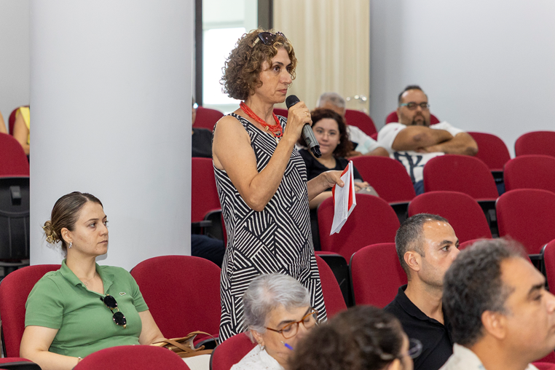

3. Surface and Coastal Flooding
Proposed Solutions: Restrict coastal construction, promote permeable ground surfaces, implement early warning systems, and improve stormwater drainage infrastructure.
Stakeholder Comments:
- AFAD: Riverbeds should not be opened for construction.
- METU Institute of Marine Sciences: Coastal ecosystems must be preserved.

4. Forest Fires
Proposed Solutions: Early warning systems, increasing the number of firefighting pools, reducing flammable plant species, ensuring electrical transmission lines are safe and, if necessary, enclosed, and maintaining technical support during the fire season.
Stakeholder Comments:
- Gülnar Municipality: Prioritize investment in preventive systems rather than solely in firefighting.
- Mersin Provincial Directorate of Disaster and Emergency Management: Ensure technical support in rural areas during the summer season and have fire trucks on standby.
- Regional Directorate of Forestry: Maintain power lines and convert them to enclosed systems.
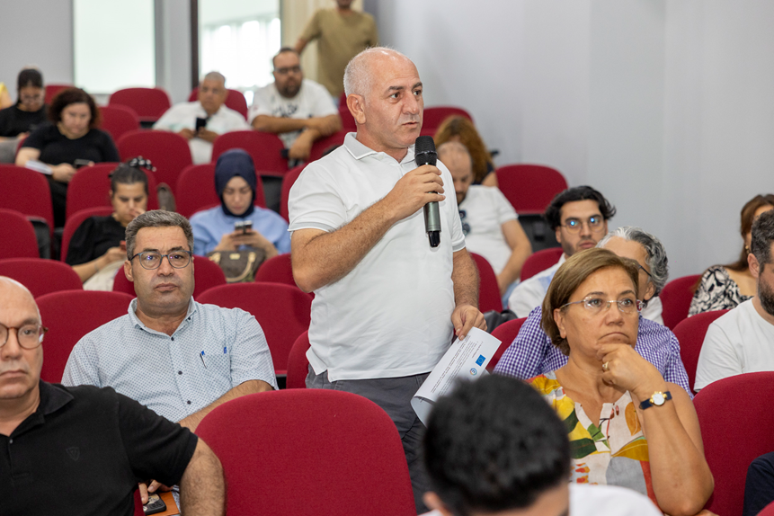

A total of 83 representatives from 45 institutions attended the event, including municipalities, public institutions, universities, professional chambers, NGOs, and private sector organizations.

This diversity demonstrated a strong example of multi-stakeholder governance.

At the conclusion of the event, stakeholders collaborated to develop adaptation strategies for Mersin’s climate resilience, focusing on heatwaves, drought, surface/coastal flooding, and forest fires.The recommendations were carefully reviewed, leading to the preparation of this report.
The Mersin Metropolitan Municipality will continue to use the global expertise gained through its ICLEI and GCoM memberships to produce local solutions via the CLIMAAX-supported MCR-RA project.
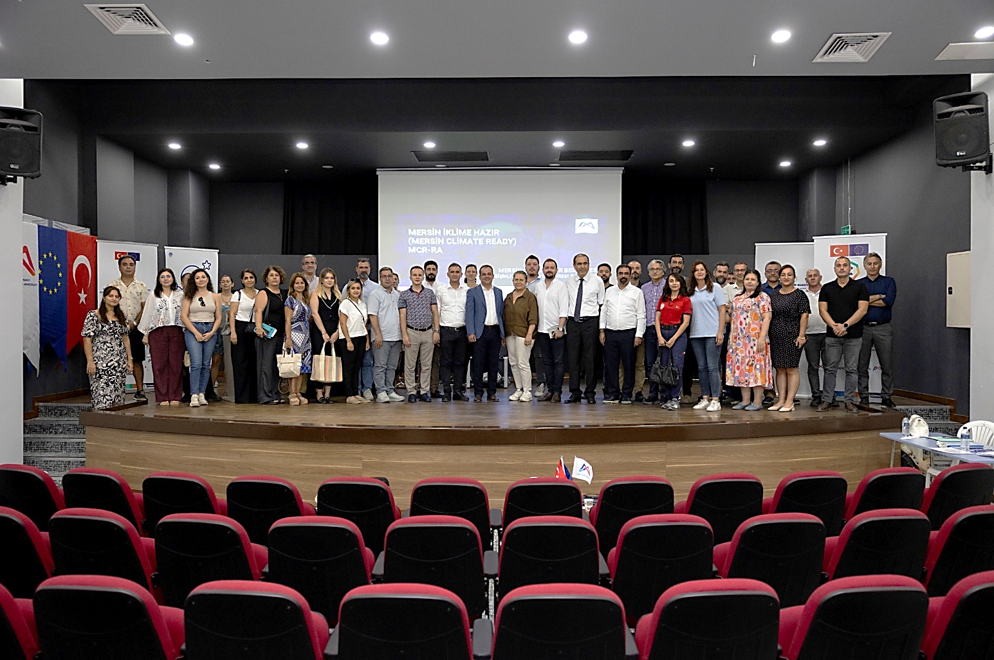

THANK YOU TO ALL PARTICIPANTS FOR THEIR CONTRIBUTIONS.

